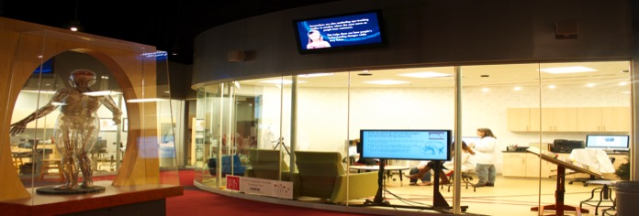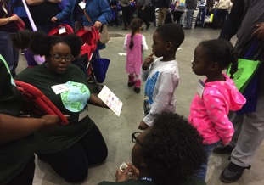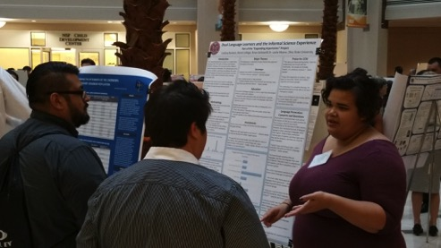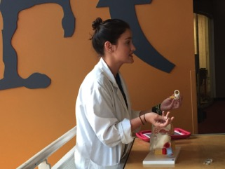

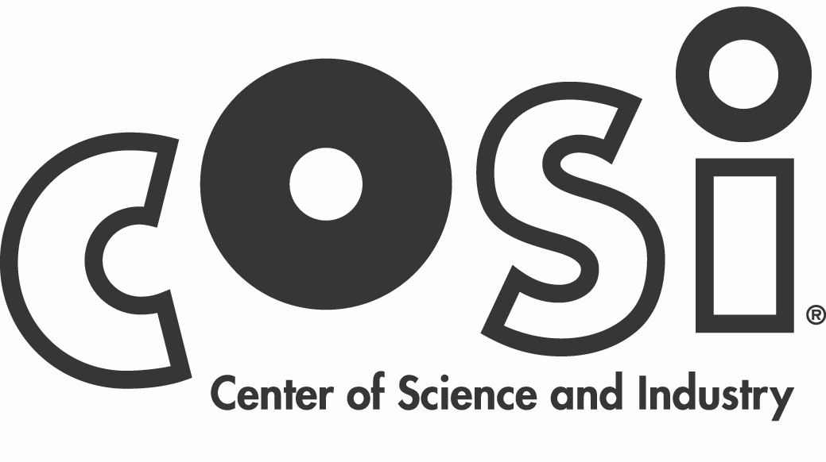



Language Sciences Research Lab

**Annual Activity Report**

**2017**

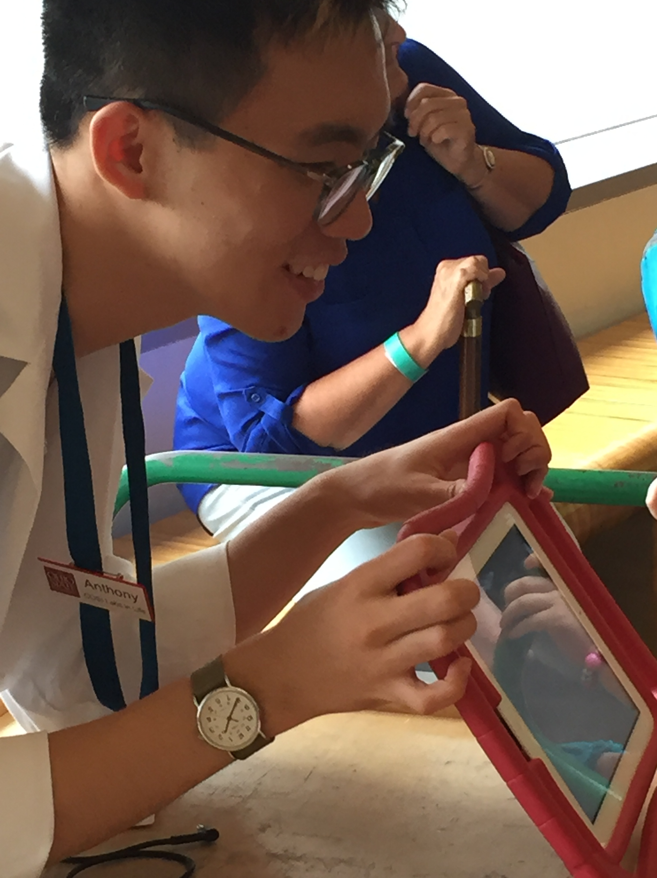

The Language Sciences Research Lab is committed to expanding access to language science along multiple dimensions. Over the past 5 years more than 17,000 visitors to the COSI museum have participated in research studies and thousands more have engaged with one of our student-led demonstration activities. We are also bringing in new students, new faculty, and new languages to reflect the true diversity of language science.

***Thank you to all our ongoing and previous sources of funding****:*  
The Departments of Linguistics, Speech & Hearing Sciences, and Psychology

The OSU Office of Research

The College of Arts & Sciences

The Division of Social and Behavioral Sciences

The OSU Office of Engagement & Impact

The Center for Cognitive & Brain Sciences

The Buckeye Language Network

The Battelle Foundation

The National Science Foundation

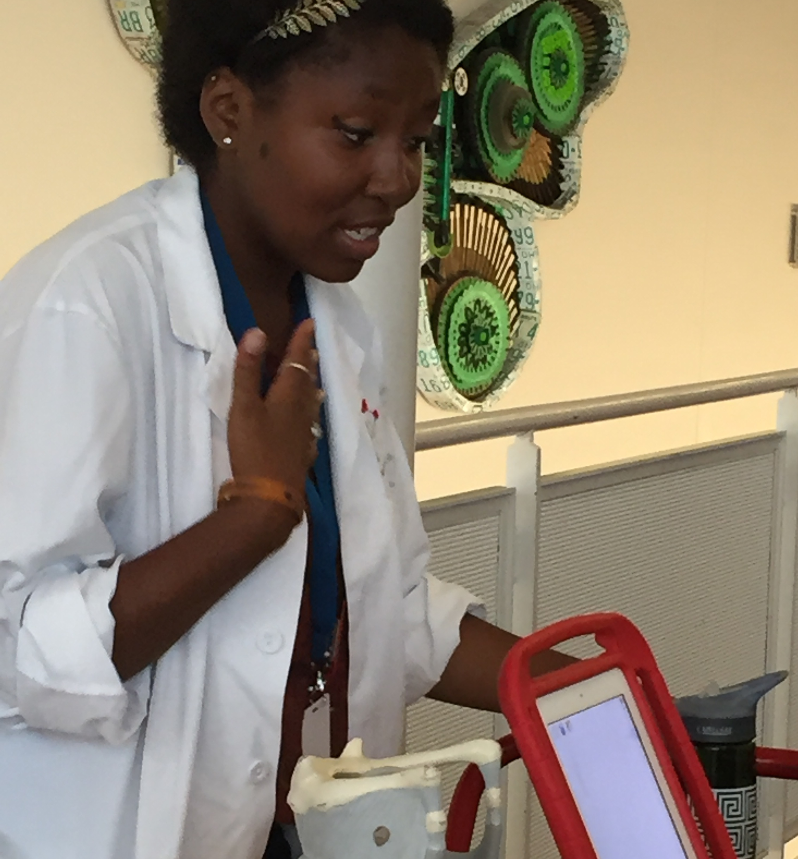

### **Broadening Participation**

Our NSF-funded Research Experience for Undergraduates Site continues to provide an intense summer experience for students from under-represented populations and students who have little access to research at their home institutions. These students conduct research with lab faculty and develop an outreach demonstration for use on the floor of the COSI museum. With the help of an NSF supplement grant, many of these students also attended the AAAS Family Science Days public outreach event.

Research conducted by summer program students has been presented at conferences around the world:

*Linguistics Society for America (Austin, TX)*

*At least one more conference   
(Not in TX)*

*Society for Research in Child Development   
(Austin, TX)*

*International Association for the Study of Child Language   
(Lyon, France)*

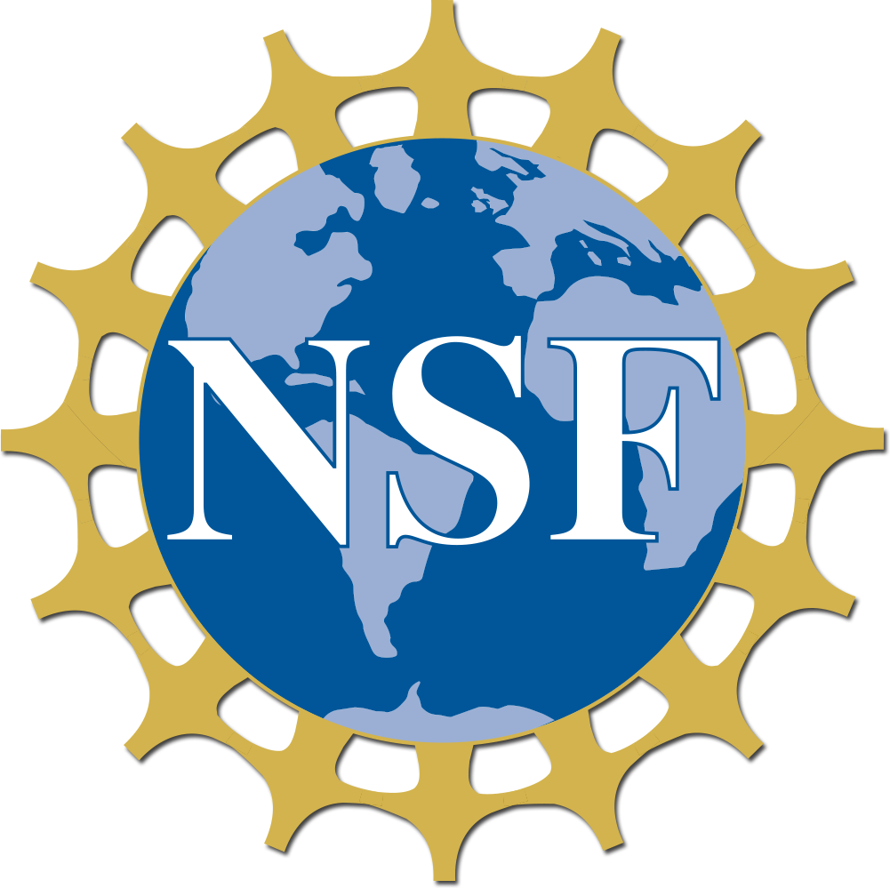

### **Student Diversity**

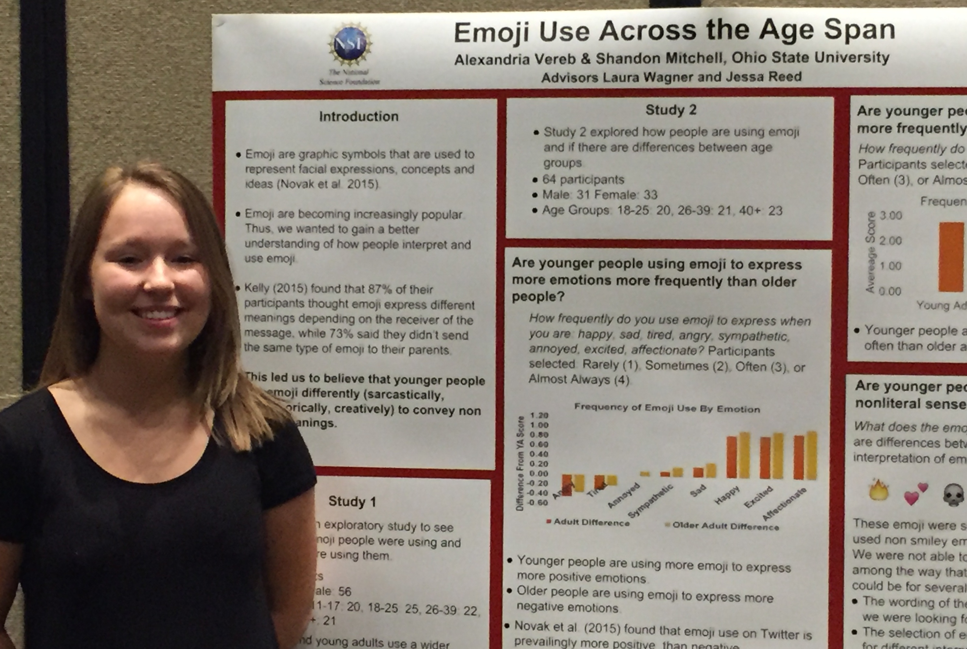

This past year we expanded our efforts to incorporate more non-English programming in our lab. We developed new outreach activities that teach visitors about other languages and in some cases, can even be conducted in other languages! We also hosted school events for the language immersion school and continue to support and encourage multi-lingualism.

COSI and OSU are multi-lingual environments and we are proud to have students who are native speakers of many different languages, including

Spanish Arabic

Korean Mandarin

Swahili French

Hindi English

Language Diversity



In conjunction with the COSI museum, Education Director Moore holds an NSF Informal Science Learning (AISL) grant looking at dual language learners and science learning in museum and preschool settings. We are working to understand and improve the way multi-lingual speakers access educational resources.

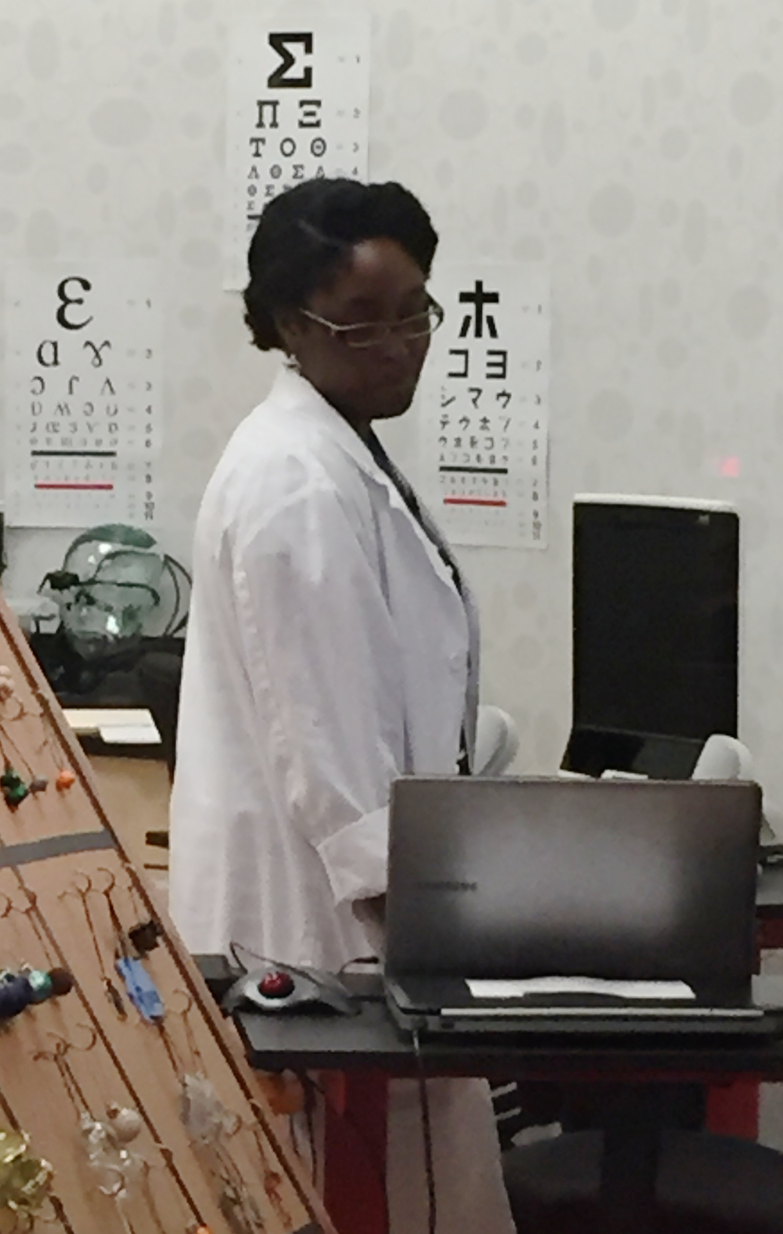

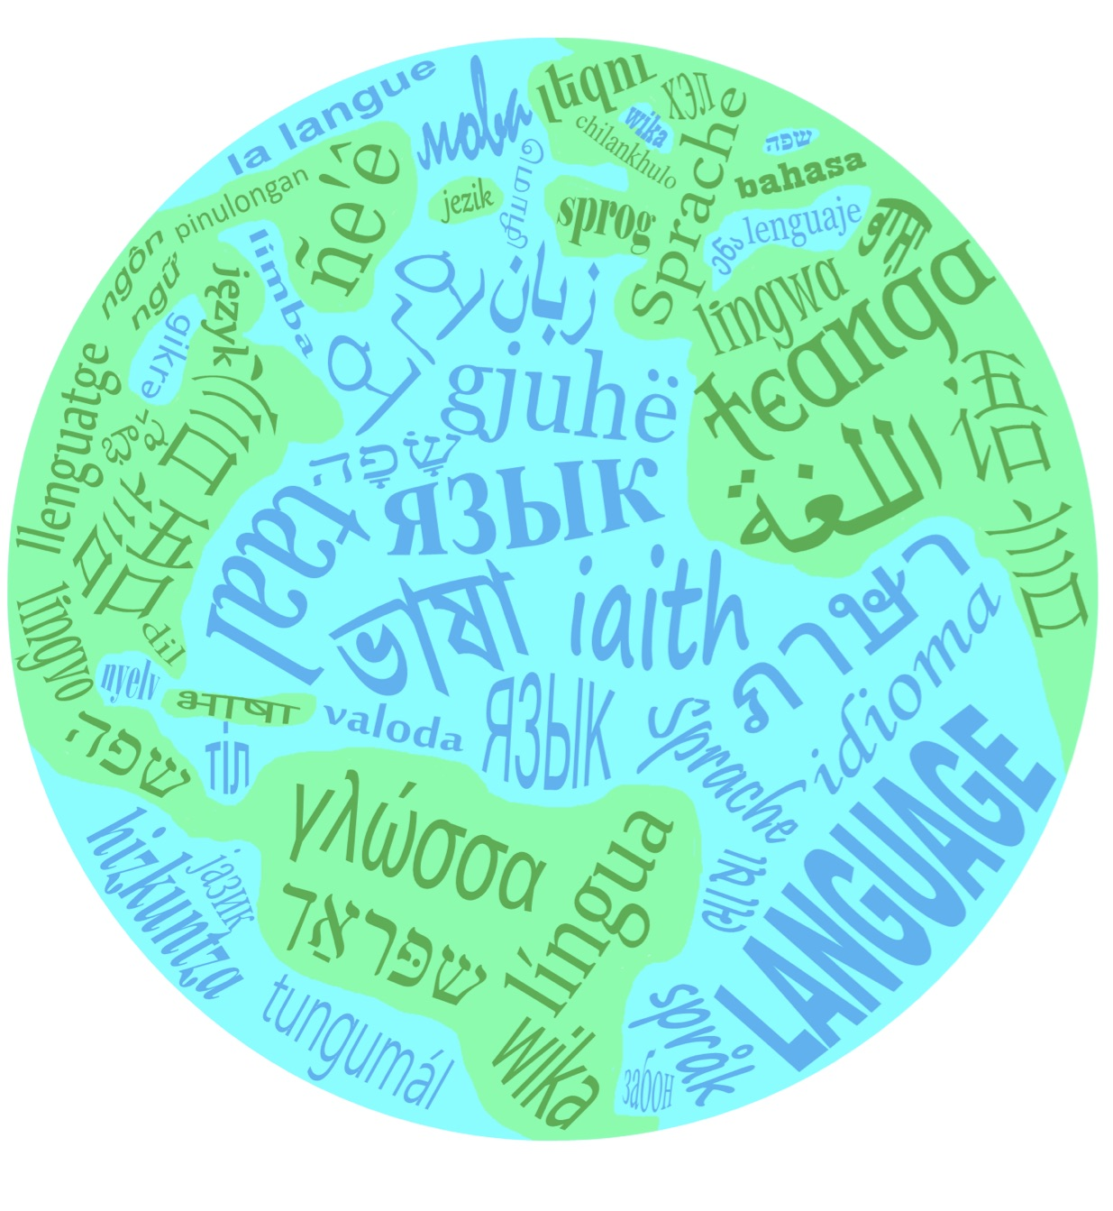

We are pleased to announce that longtime lab researcher Rachael Frush Holt, Associate Professor in the Department of Speech and Hearing Sciences has joined the lab’s executive committee as our Advancement Director.

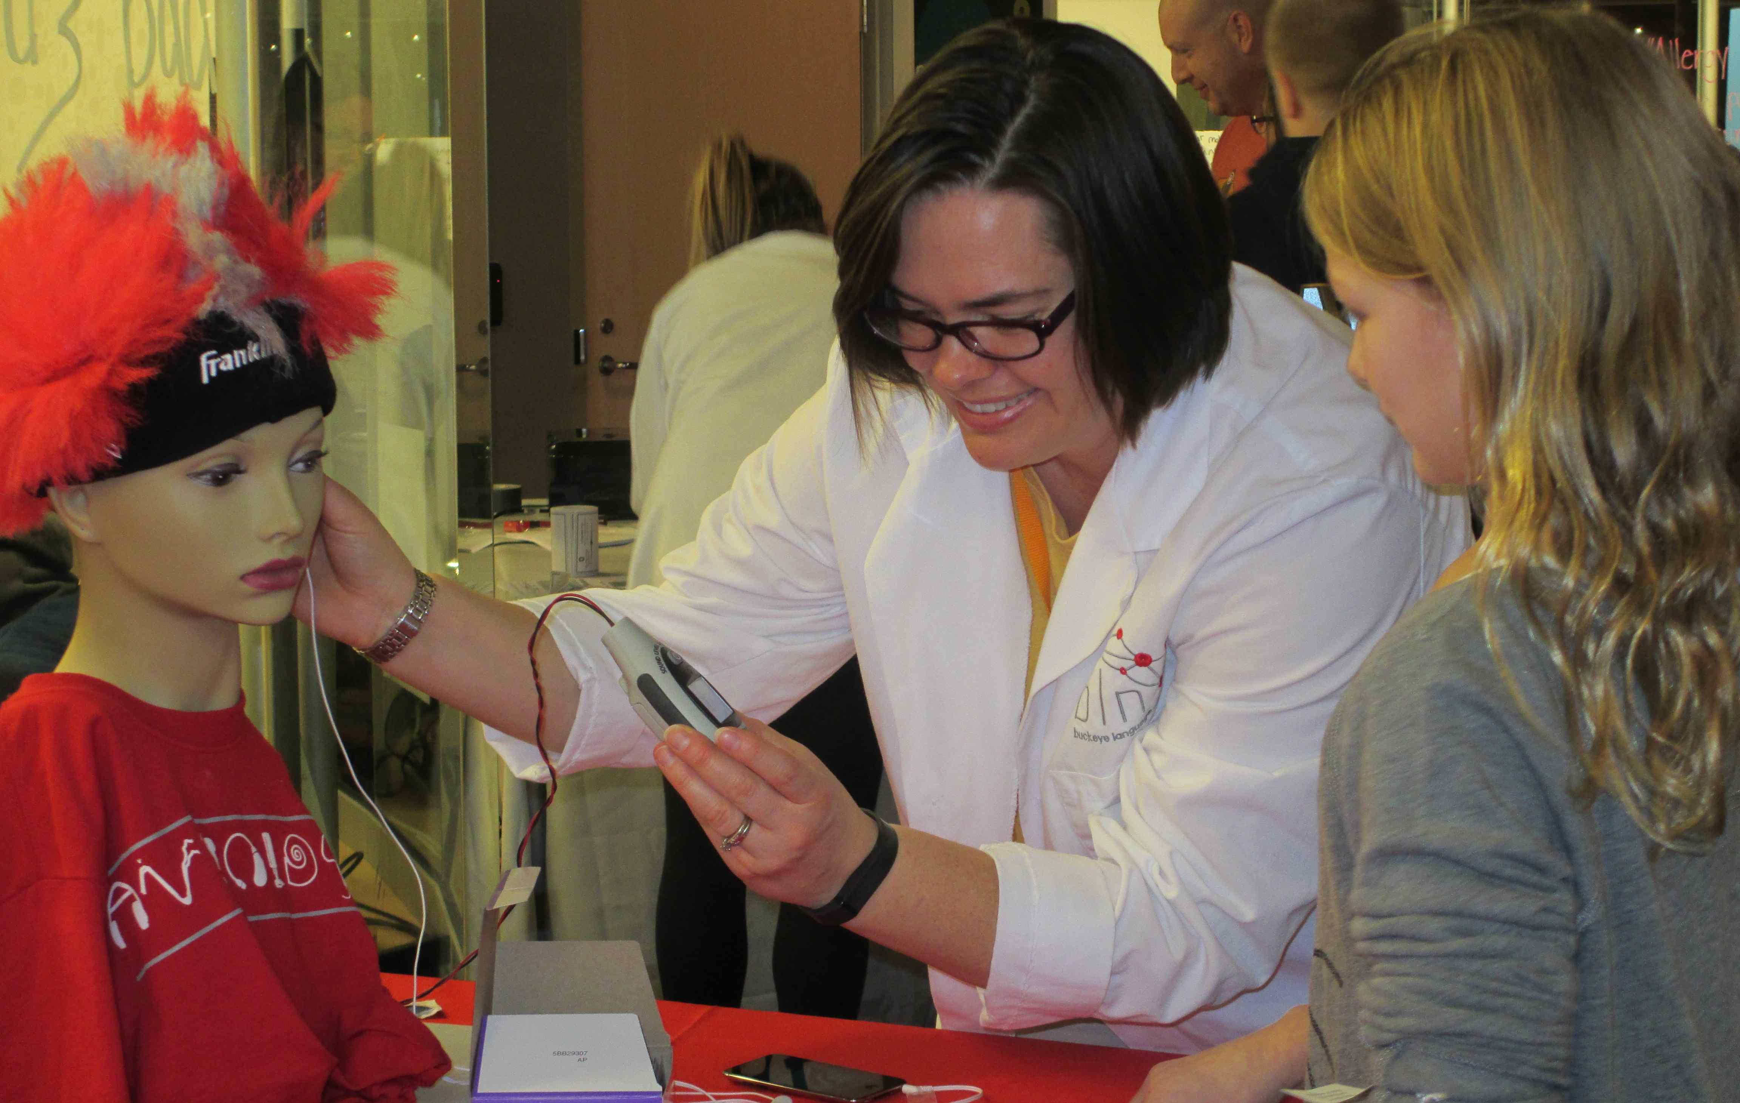

Language science research requires multiple perspectives and our research faculty come from a diverse range of colleges and departments from across the university, including Linguistics, Psychology, English, Teaching & Learning, Music, and Computer Science. New faculty join the lab every year, expanding the range of studies we conduct with the public.

Jennifer Lundine

Assistant Professor

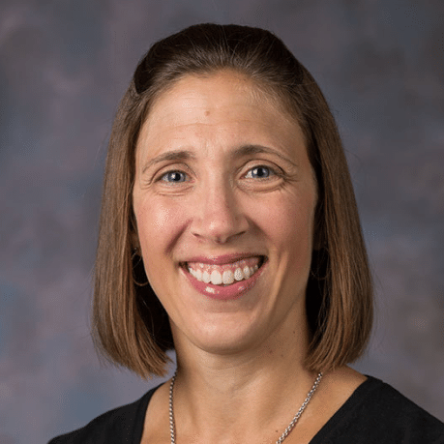

**Welcome to our new researchers from the department of Speech & Hearing Sciences!**

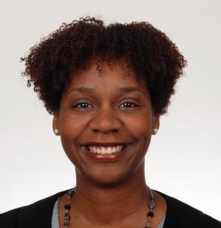

Monique Mills

Associate Professor

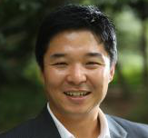

Yune Lee

Assistant Professor

Faculty Diversity

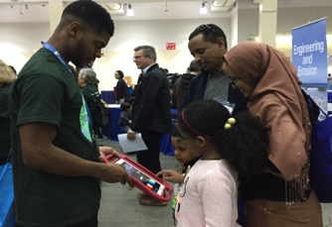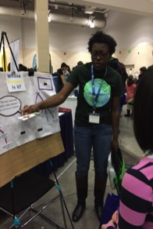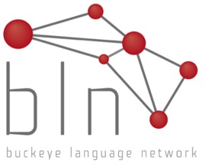

**Laura Wagner, Director**  
Associate Professor, Department of Psychology

**Kathryn Campbell-Kibler, Outreach Director**  
Associate Professor, Department of Linguistics

**Cynthia Clopper, Research Director**  
Professor, Department of Linguistics

**Rachael Frush Holt, Advancement Director**  
Associate Professor, Department of Speech & Hearing Sciences

**Kiwako Ito, Eye-Tracking Coordinator**  
Research Scientist, Department of Linguistics

**Leslie C. Moore, Educational Director**  
Associate Professor, Department of Teaching and Learning

**Shari Speer, Research Director**  
Professor, Department of Linguistics

Contact email:[**bln@osu.edu**](mailto:bln@osu.edu)

Visit our website:

u.osu.edu/thebln

Follow us on Facebook:[www.facebook.com/  
BLNLanguagePod](https://www.facebook.com/BLNLanguagePod)

**Language Sciences Research Lab Executive Committee**